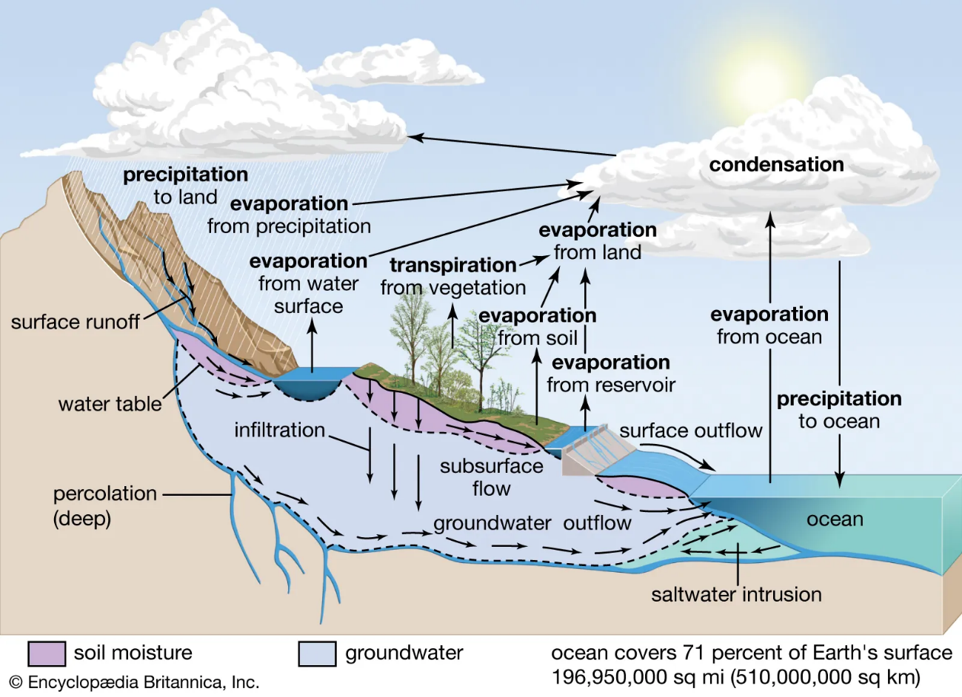
NPC DIALOGUE for the HYDROLOGICAL CYCLE BUILD (Copy and Paste)
MASSIVE USFUL INFO HERE READY FOR NPCs

- Stage 1: Evaporation. When the sun heats up water in rivers, lakes, and oceans, it turns into water vapor that rises into the sky. This process is called evaporation and is the first stage of the hydrological cycle. Water vapor forms clouds in the atmosphere that move with the wind.
- Stage 2: Condensation. As water vapor rises in the atmosphere, it cools down and turns back into liquid water droplets. This process is called condensation and is the second stage of the hydrological cycle. These water droplets combine with other droplets to form clouds.
- Stage 3: Precipitation. When the water droplets in the clouds become too heavy, they fall to the ground as precipitation. This can be in the form of rain, snow, sleet, or hail. Precipitation is the third stage of the hydrological cycle and is essential for life on earth.
- Stage 4: Infiltration. Some of the precipitation that falls on the ground seeps into the soil and becomes groundwater. This process is called infiltration and is the fourth stage of the hydrological cycle. Groundwater can be used by plants, animals, and humans or can continue to flow through the soil to become surface water.
- Stage 5: Runoff. Some of the precipitation that falls on the ground does not infiltrate the soil and becomes surface runoff. This is the fifth stage of the hydrological cycle and can cause erosion and transport pollutants from the surface to bodies of water.
- Stage 6: Streamflow. When surface water and groundwater come together, they form streams and rivers. This is the sixth stage of the hydrological cycle, known as streamflow. Streamflow can be influenced by precipitation, infiltration, and runoff.
- Stage 7: Storage. Water can be stored in different places, such as lakes and underground aquifers. This is the seventh stage of the hydrological cycle and is important for maintaining a consistent supply of water for human, plant, and animal use.
- Stage 8: Transpiration. Plants absorb water through their roots and release it into the atmosphere as water vapor through their leaves. This process is called transpiration and is the eighth and final stage of the hydrological cycle. Transpiration helps to maintain a balance of moisture in the environment.
- Stage 9: Sublimation. This is when water changes from a solid (ice or snow) directly into water vapor without first melting into liquid water. This process occurs more commonly in very cold and dry environments, such as in the polar regions.
- Stage 10: Percolation. This is when water moves downward through soil and rock due to gravity. This process can transport water deep underground, where it can be stored in aquifers for long periods of time.

POSSIBLE LINKS TO ADD TO NPCS AT EACH STATION
- Stage 1: Water Evaporation
- USGS Water Science School: Evaporation: https://www.usgs.gov/special-topic/water-science-school/science/evaporation-water
- NASA Climate Kids: Evaporation: https://climatekids.nasa.gov/evaporation/
- Weather Wiz Kids: Evaporation: https://www.weatherwizkids.com/weather-water-cycle-evaporation.htm
- National Geographic Kids: Evaporation: https://kids.nationalgeographic.com/science/article/evaporation
- Stage 2: Cloud Formation
- NOAA SciJinks: Clouds: https://scijinks.gov/clouds/
- National Geographic Kids: Clouds: https://kids.nationalgeographic.com/science/article/clouds-101
- Met Office: How clouds form: https://www.metoffice.gov.uk/weather/learn-about/weather/atmosphere/how-do-clouds-form
- The Water Cycle for Schools: Clouds: https://water.usgs.gov/edu/watercycleclouds.html
- Stage 3: Precipitation
- UCAR Center for Science Education: Precipitation: https://scied.ucar.edu/shortcontent/precipitation-overview
- NASA Climate Kids: Precipitation: https://climatekids.nasa.gov/precipitation/
- Weather Wiz Kids: Precipitation: https://www.weatherwizkids.com/weather-rain.htm
- National Geographic Kids: Precipitation: https://kids.nationalgeographic.com/science/article/precipitation
- Stage 4: Infiltration
- USGS Water Science School: Infiltration: https://www.usgs.gov/special-topic/water-science-school/science/infiltration-percolation-water-cycle
- The Water Project: Infiltration: https://thewaterproject.org/water-cycle/infiltration
- Science Learning Hub: Infiltration: https://www.sciencelearn.org.nz/resources/2197-infiltration
- The Water Cycle for Schools: Infiltration: https://water.usgs.gov/edu/watercycleinfiltration.html
- Stage 5: Surface Runoff
- National Geographic Kids: Runoff: https://kids.nationalgeographic.com/science/article/runoff
- USGS Water Science School: Runoff: https://www.usgs.gov/special-topic/water-science-school/science/runoff-water-cycle
- Weather Wiz Kids: Runoff: https://www.weatherwizkids.com/weather-water-cycle-runoff.htm
- The Water Cycle for Schools: Runoff: https://water.usgs.gov/edu/watercyclerunoff.html
- Stage 6: Streamflow
- USGS Water Science School: Streamflow: https://www.usgs.gov/special-topic/water-science-school/science/streamflow-water-cycle
- National Geographic Kids: Streams and Rivers: https://kids.nationalgeographic.com/science/article/streams-and-rivers-101
- The Water Project: Streamflow: https://thewaterproject.org/water-cycle/streamflow
- Science Learning Hub: Streams and Rivers: https://www.sciencelearn.org.nz/resources/2265-streams-and-rivers
- Stage 7: Water Storage
- Water Education Foundation: Water Storage: https://www.watereducation.org/education/water-storage
- The Water Cycle for Schools: Water Storage: https://water.usgs.gov/edu/watercyclestorage.html
- USGS Water Science School: Water Storage: https://www.usgs.gov/special-topic/water-science-school/science/water-storage-water-cycle
- Stage 8: Groundwater
- USGS Water Science School: Groundwater: https://www.usgs.gov/special-topic/water-science-school/science/groundwater-and-water-cycle
- National Geographic Kids: Groundwater: https://kids.nationalgeographic.com/science/article/groundwater
- The Water Project: Groundwater: https://thewaterproject.org/water-cycle/groundwater
- EPA: Groundwater and the Water Cycle: https://www.epa.gov/water-research/groundwater-and-water-cycle
- Stage 9: Transpiration
- Science Learning Hub: Transpiration: https://www.sciencelearn.org.nz/resources/138-transpiration
- National Geographic Kids: Transpiration: https://kids.nationalgeographic.com/science/article/transpiration
- USGS Water Science School: Transpiration: https://www.usgs.gov/special-topic/water-science-school/science/transpiration-water-cycle
- The Water Cycle for Schools: Transpiration: https://water.usgs.gov/edu/watercycletranspiration.html
- Stage 10: Water Collection
- Water Education Foundation: Water Collection: https://www.watereducation.org/education/water-collection
- The Water Project: Water Collection: https://thewaterproject.org/water-cycle/water-collection
- USGS Water Science School: Collection of Water: https://www.usgs.gov/special-topic/water-science-school/science/collection-water-water-cycle
- EPA: Water Collection and Treatment: https://www.epa.gov/water-research/water-collection-and-treatment

