Energy Conversions Grade 7 Science
- Light energy can be converted to heat energy.
- Electrical energy can be converted to mechanical energy, light energy, heat energy, etc.
- Chemical energy can be converted to electrical energy.
- Thermal energy can be converted to heat energy.
- Mechanical energy can be converted to electrical energy, potential energy, etc.
- Nuclear energy can be converted to light energy and heat energy.
- The Solar energy can be converted to heat energy, chemical energy, and electrical energy.
- The Gravitational potential energy can be converted to kinetic energy.

Some examples of energy conversion are:
- A vehicle moving is an example of chemical energy being converted into kinetic energy.
- Electricity being produced with water is an example of potential energy being converted into kinetic energy.
- A ball from a height towards the ground is an example of potential energy being converted into kinetic energy.
- When you boil water using an electric kettle, it’s an example of electric energy being converted into heat energy.
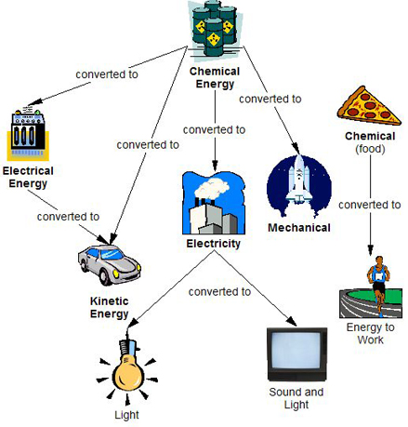
1-Give an example of Electrical Energy being converted into light energy (you do this every day at home)
2-Give an example of chemical energy being converted to electrical energy (Think water animals)
3-Give an example of electrical energy being converted to kinetic energy
4-Give an example of Solar energy being converted to electrical energy
5-Give an example of light energy being converted to heat energy

